# Digital image processing – EXAM summary

## Outer Imaging Chain

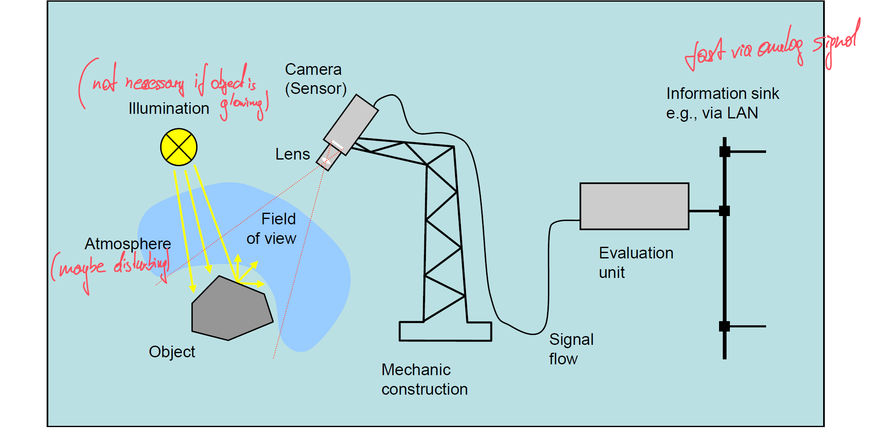

## CCD – Charge Coupled Device

* picture elements – pixel – are capacitors which are chard by luminous flux
* at defined shutter speed the charging voltage corresponds to image brightness
* example: **interline transfer sensor:** pixel are exposed at the same time readout is done serial by vertical and horizontal shift registers
* coused by TV norm the interlaced readout is common too

STEPS CCD-CAPTURE:  
1. Discharge – Up=0V  
2. Expose CCD ET~0,5-20 ms  
3. Stop exposure  
4. Readout – Shift Register y+x direction

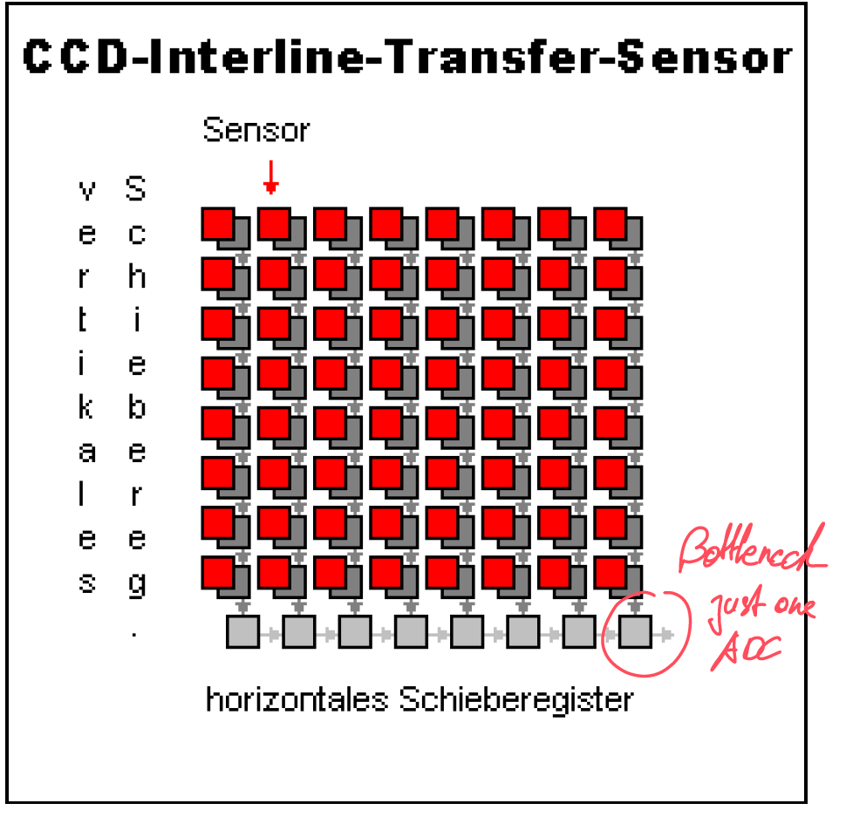

## CMOS-Sensor

**CCD sensor including transistors for evaluation “APS – active pixel sensor”**

* each pixel additionally to the capacitor contains one or more transistors driving the raw analog signal – in CMOS technology
* modifying the characteristic of sensitivity
* fill factor decreases (CCD ~90% -> CMOS ~30%)
* “high dynamic range” – HDR

**Photo diode array**

* Impact of photons affects conductance
* Continuous image conversion
* No shutter time
* Reading of certain regions within the image possible
* High noise

## Event Based Camera – Dynamic Vision Sensor DVS

* Meaning: does not take frame by frame but reacts on events – changes in brightness – per pixel
* Static image – no events – no output
* Dynamic image – registers only changing events per pixel
* Down to 1200 events per second

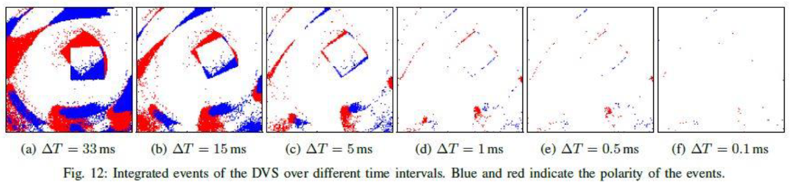

## Camera features – specifications

* “the camera is the sensor of light; it delivers electrical signals (analog) or digital numbers representing the brightness of the senery”
* 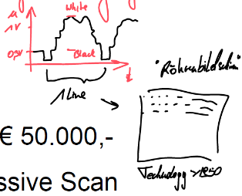**Geometry:** matrix / area scan camera, line scan camera
* **Video signal:** analog, digital camera
  + Analog in private: chemical process of image – film
  + Analog in industry: according to signal transfer
* Sensor type (& format):
  + CCD, CMOS, photo diode array / BW, Color
  + Special cameras – e.g. thermal imaging -40°C to 1600°C, delta T ~0,1°C (€20K – €50K)
  + Capturing procedure: interlaced, non-interlaced = progressive scan
* Intelligent cameras:  
  capturing device including evaluation device (CPU, Ethernet connected)
* Manufacturer: JAI, SONY, DALSA, PULIX, FLIR, COGNEX, OMRON
* Costs: €500,- to €2000,-

## Optical Path – law of image mapping – lens equation – focal distance

Model of the thin lens

 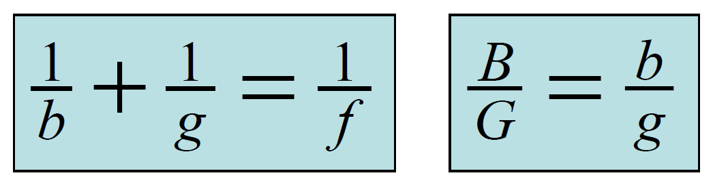

g... Distance object to lens  
b... Distance lens to image  
f... focal distance  
G... Size of the object  
B... Size of the image

B/G=m ... Sacle of mapping

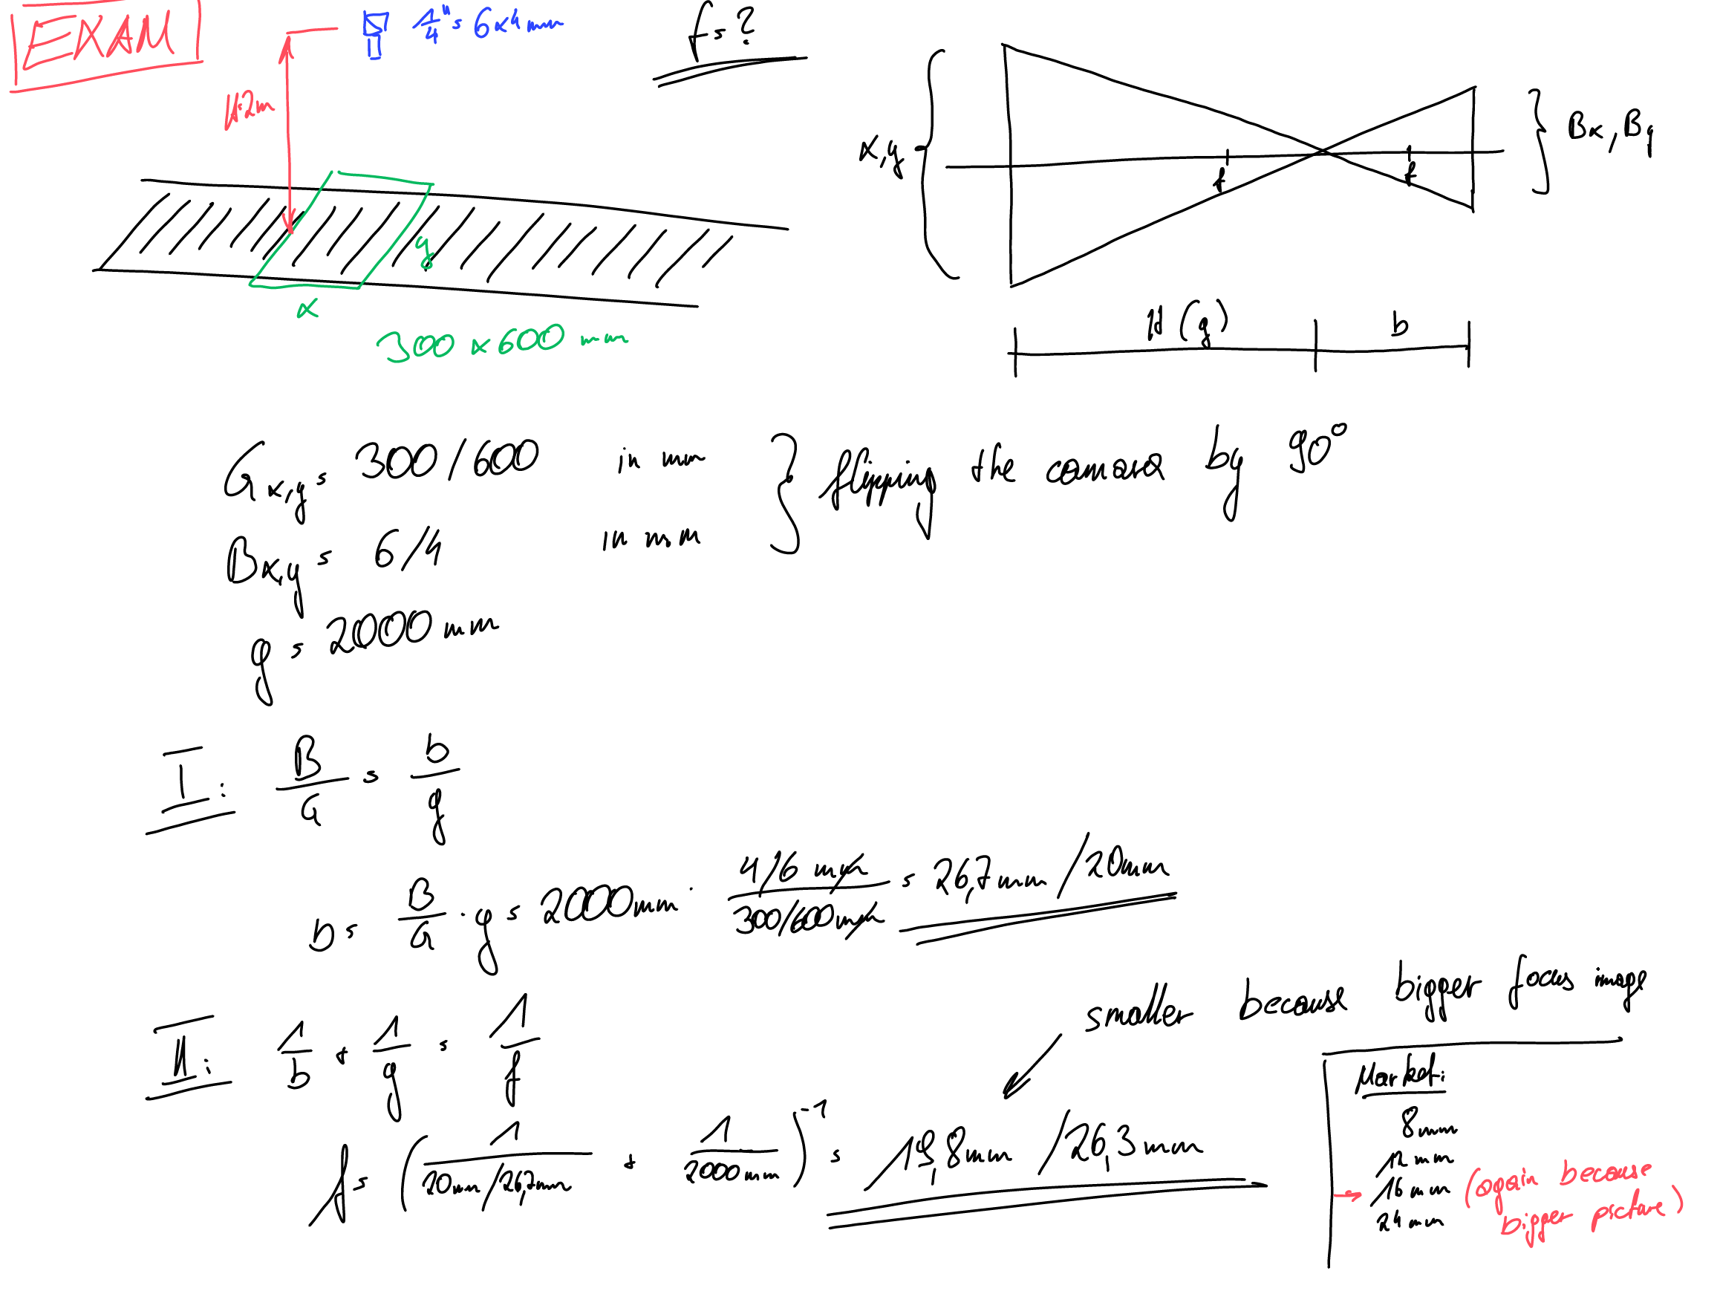

## Optical path – iris

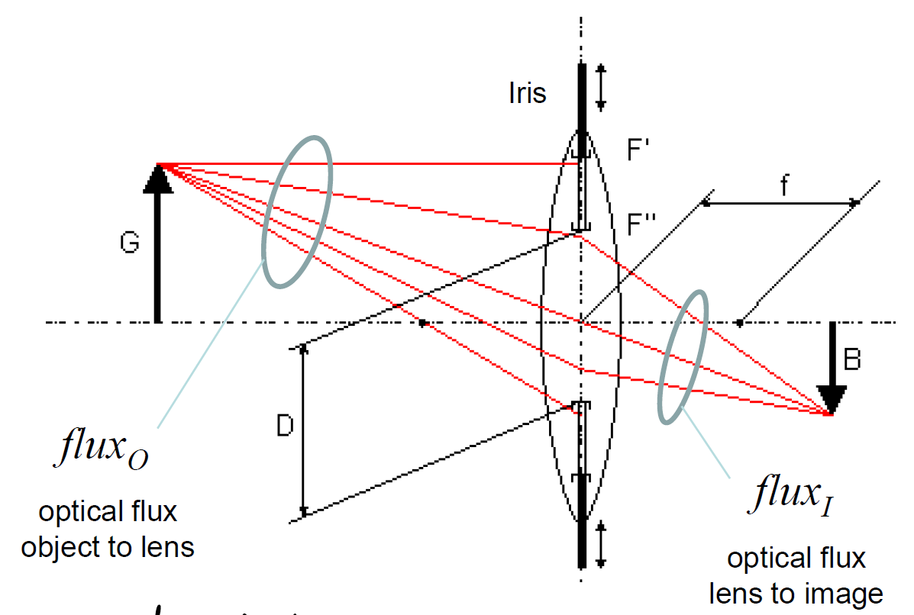

The iris closes a part of the optical beams which enter the front pupil – control the brightness

By modifying the size of the free iris diameter (the aperture) the brightness of the image can be adjusted.

D... free diameter of the iris

f-number, f-stop

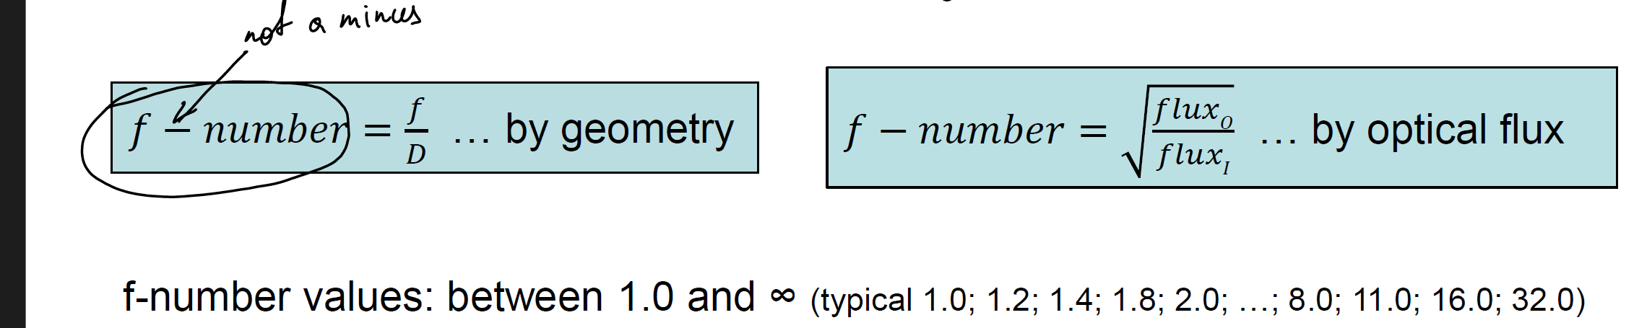

## Optical path – iris – depth of sharpness

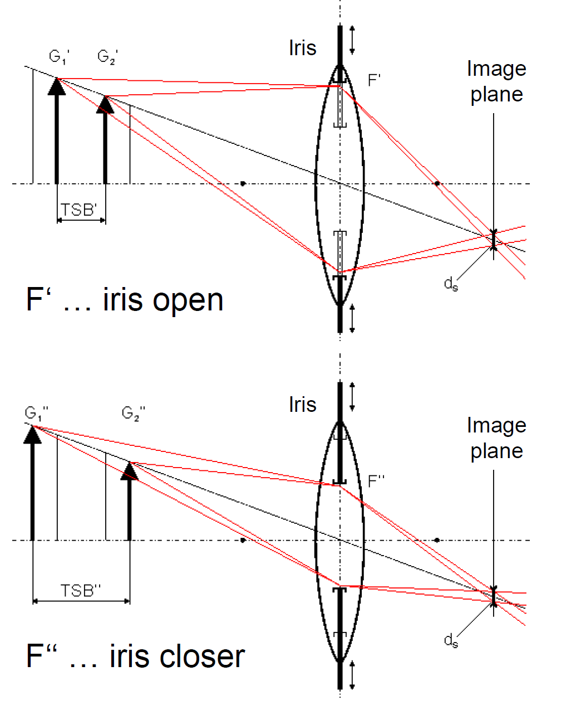

Ds.. blur diameter for acceptabel sharpness – size of the pixel

TSB’...at open iris  
TSB’’...at closer iris

Relationship – depth of sharpness (DOS) & f-number

Big f-number -> big DOS

Relationship – depth of sharpness (DOS) & iris

Bigger iris -> smaller DOS

## Pinhole Camera – optical path

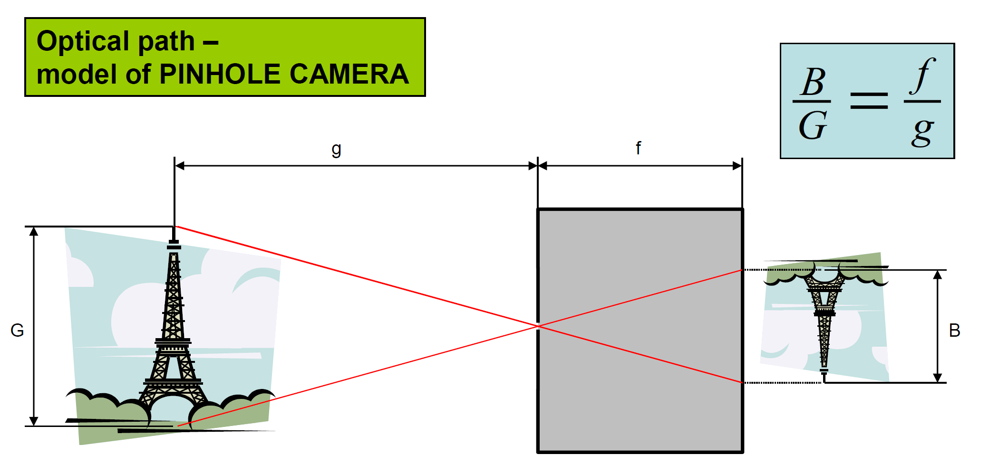

* Pinhole -at the back side of the box there is a semitransparent material – the object can be seen at this image plane
* Pinhole – compared to iris whisch si very close -> DOS is very big

## Optics – sharpness vs. F-number

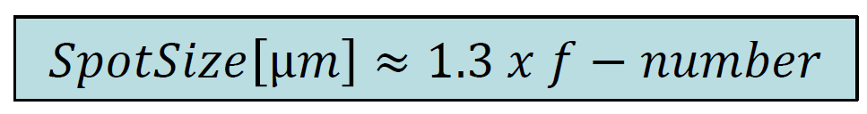

e.g: f-number=2.2 -> SpotSize = 2.86µm   
🡪 Samsung S4 camera : 13 MP, 1/3“, 1.14 µm, f/2.2, F 31 mm

## Lens features – specifications

* “the lens projects the scene to the sensor plane”
* Features for selecting the lense:  
  **Focal distance**, **mechanical mounting**, **sensor format**, minimal f-number, distortion, mechanical stability
* **Mechanical mounting**: C-Mount / CS-Mount (camera assembly)
* **Sensor format**: has to fit to the CCD format of the camera
* Tele centric lens  
  -> takes parallel beams from the object only
* Narrow lens / spacer ring / macro lens  
  -> reduction of the minimal distance to the object
* Fisheye / extra wide angle
* Manufacturer: COSMICAR, PENTAX, SCHEIDER-KREUNACH, ZEISS,...
* Costs: €300,- to €2000,- (tele centric 8k – 20k)

## Illumination Types

* Transmitted light  
    
  object transparent for certain spectral wavelength
* Silhouette projection  
    
  shadow is detected -> binary image – for precise measurements
* Incident light
  + Diffuse – no shadows   
    
  + Bright field – reflecting object in dark ambience  
    
  + Dark field – for detecting notches and scratches   
    
* Shade projection – when grey level of object & background are similar  
  
* Structured illumination – outline & features of 3D objects  
  

## Artificial light sources

Not all light sources are qualified for optical metrology e.g. low quality – very cheap but very low light efficiency etc.

Essential sources:

* Fluorescent tube (missing colour parts)  
  bright, homogeneous light, brightness oscilates by 100Hz -> HF power supply (e.g. 2kHz) odr 3 phase powered (one tube for each phase)
* Halogen bulb (heat readiator)  
  powered by controlled DC -> precis metrology using IR/vis. Refractors (glasfibre) – just visible light goes to object -> no extra heat -> “cold light source”
* Light emitting diode LED  
  high life cycle (15000h – 30000h); short pulses; IR-LED
* LASER  
  structured light, mostly red – monochrome light

## Discrete coordinates & discrete image geometry

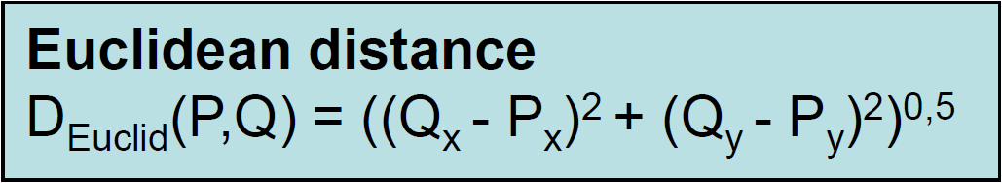





## Software Categories

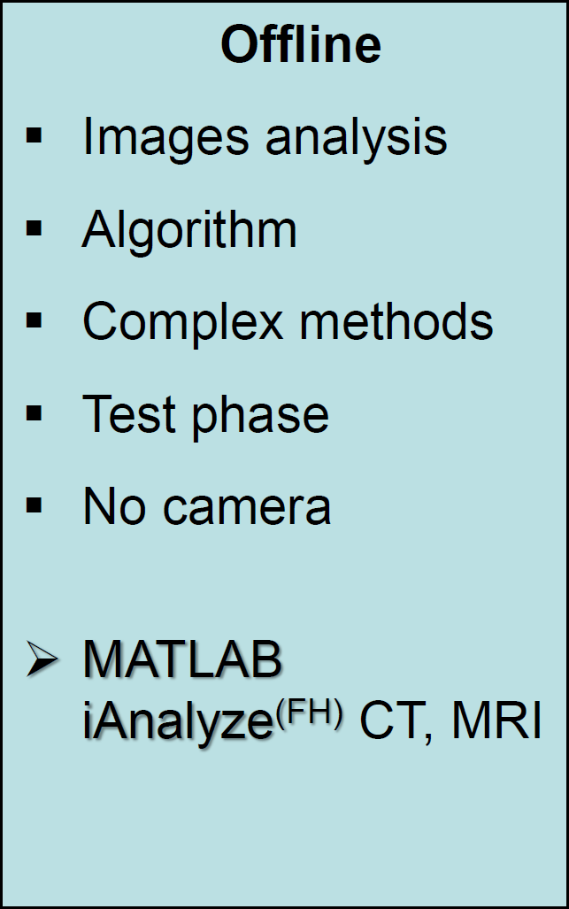 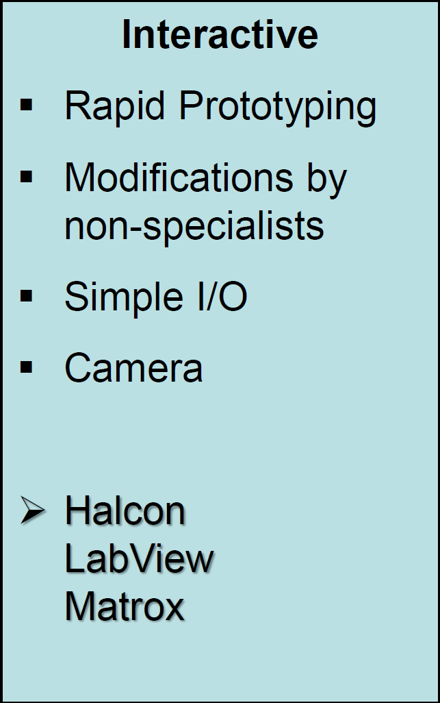 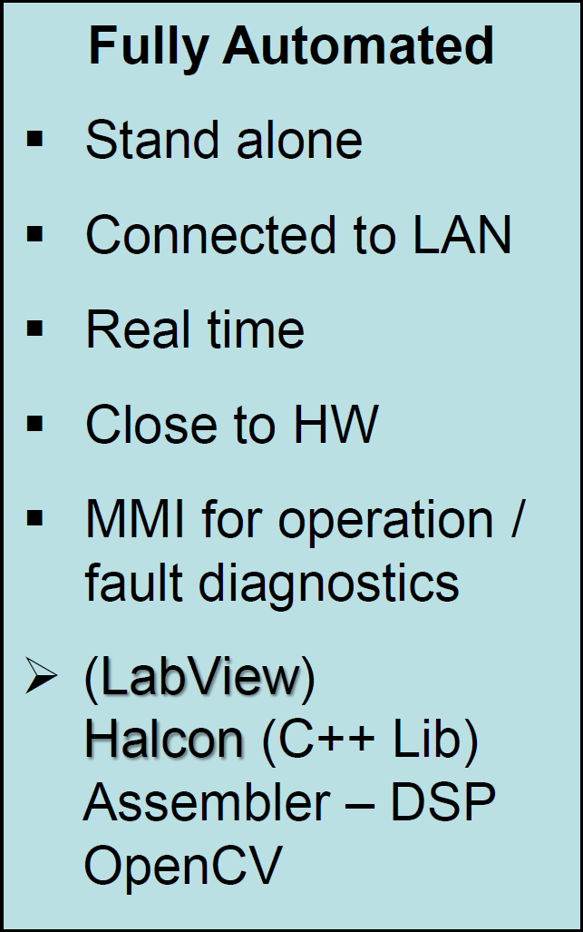



Stereography

* Estimation of the depth resolution
* The depth resolution is the minimal distance ΔH which a point has to move in the direction of the beam of one camera to cause a shifting at the other camera by the pixel distance Px.

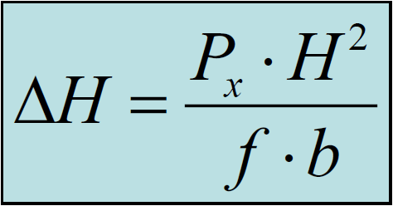 Precondition: b<<H, Px<<f and ΔH<<H

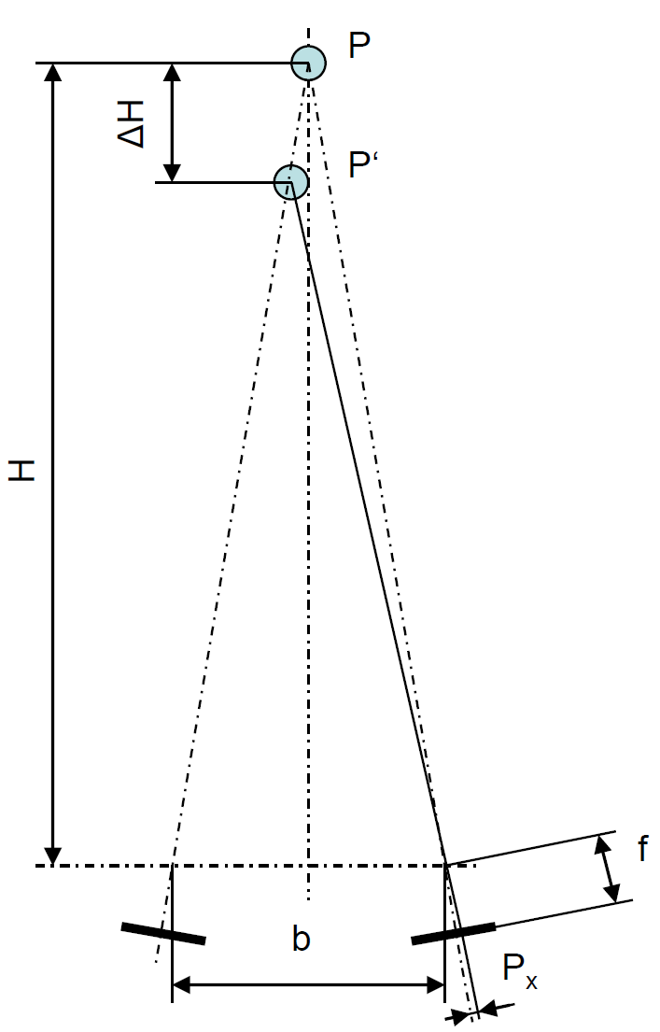

## Stereography – Summary of terms

* Pinhole  
  uses a small aperture to project an inverted image onto a photosensitive surface
* Baseline   
  refers to the distance between two observation points (or cameras) used to create depth perception in 3D imaging
* Standard geometry  
   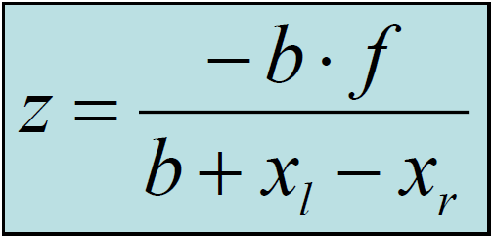 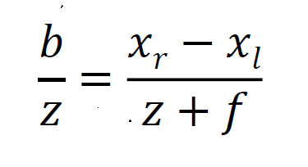
  + both imaging planes are identical
  + both optical axis are parallel
  + lines of the stereo images are parallel to the base line
* Disparity  
  difference in image location of an object seen by each camera; circular for depth perception in 3D imaging
* Rectification of the real geometry  
  refers to the process of aligning images from two cameras to a common plane; simplifying disparity calculation an enhancing 3D depth accuracy
* Epipolar geometry  
  defines geometric relationship between two camera views, constraining corresponding image points to lay along epipolar lines
* Depth resolution  
  is the accuracy in measuring depth differences between objects, influenced by factors like baseline distance and camera resolution

## Triangulation – Projection of beams of light



* Capturing the point of light at the object
  + By means of a line scan camera
  + By means of a PSD (position sensitive device) – each mx a value
* Generation of images by scanning the object in x- and y-direction

## Triangulation – Projection of planes of light



* Light sectioning method
* Generation of images by scanning the object cross the light sectioning plane respectively

## Coded Structured Light – Triangulation

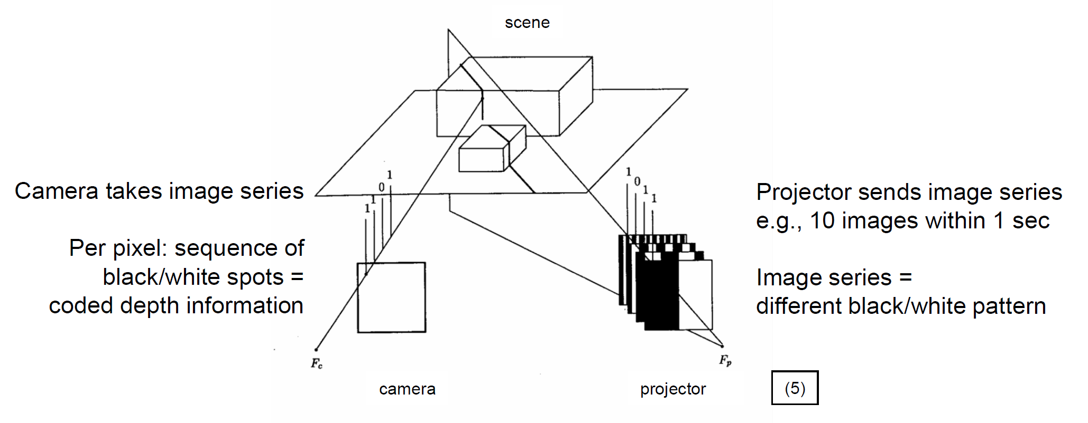

* By means of n projected plane pattern 2nd light planes can be achieved
* Per pixel: sequence of black/white spots = coded depth information projector sends image series e.g. 10 images within 1 sec

## Time of flight – TOF

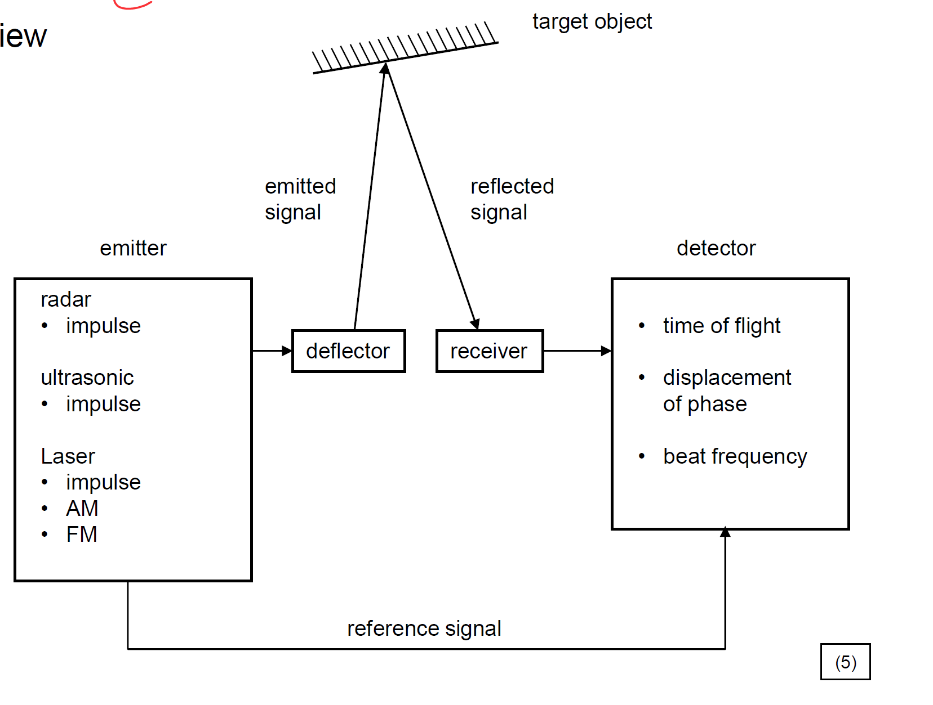

Features:

* Collimating ability
* Speed of propagation
* Reflection property by the target object
* Flare angel determines lateral resolution
* Time resolution of the electronics (detection time of flight) determines depth resolution:  
  e.g. sonic: v = 330 m/s -> 1 cm depth -> 60 µs time resolution  
  e.g. light: v = 3 x 10 8 m/s -> 1 cm depth -> 67 ps time resolution

## Paper Camera Calibration

What is the given calibration procedure at the paper?  
They have 4 different grids on different position -> estimate the min error -> homography

“The calibration is mainly based on several perspective projections, which are successively executed. In each step, the linear system of homogeneous equations is solved by using singular value decomposition.”

What is the meaning of the light sectioning method?   
-> Script - Laser beam breaking and so on....

The **light sectioning method** uses a projected line or stripe of light on a surface to measure its 3D shape by capturing the light's deformation with a camera, providing precise surface profile data.

## Homography in P²

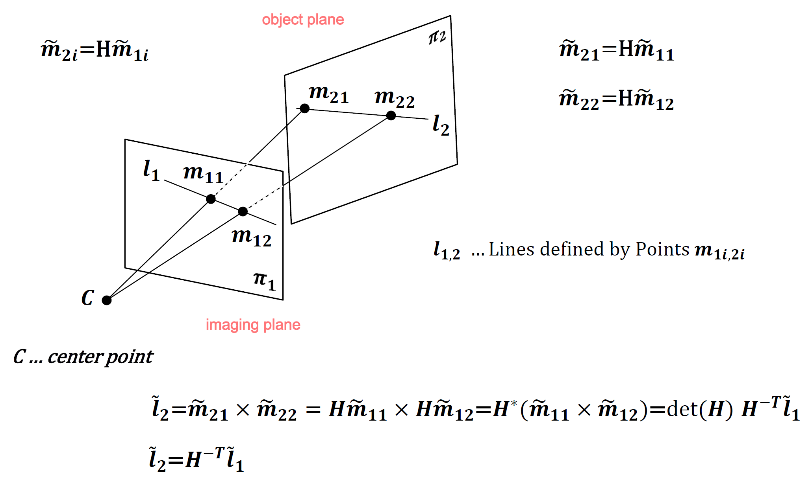

## Hierarchy of Transformations

Different geometric levels:

* **Euclidean**: Preserves distances and angles (e.g., rotation, translation).
* **Affine**: Preserves parallel lines but not distances or angles (e.g., scaling, shearing).
* **Projective**: Preserves straight lines but can distort parallelism and distances (e.g., perspective transformations).

## Affine Mapping as a subgroup of Projective Mapping

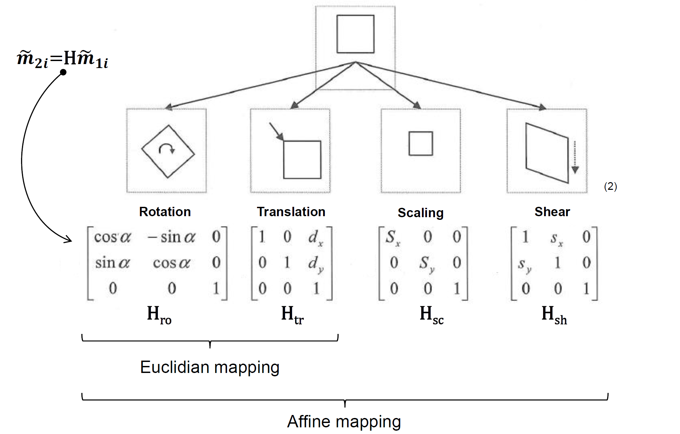

## Lens Distortions

Barrel & Pillow Distortion

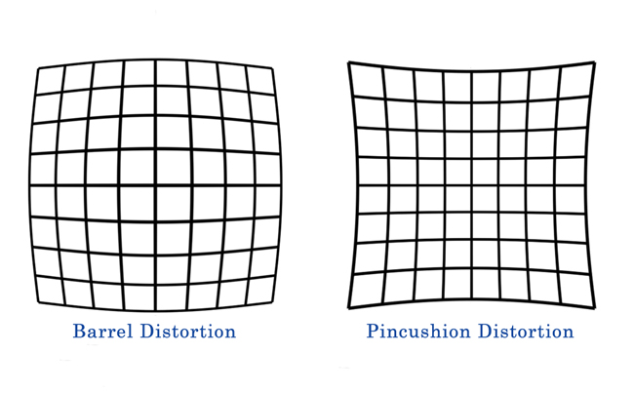

# Erdstall

Metrology by LiDAR (Leica product)

Pro:

* long range 0,5 – 100m
* Accurate, reliable – within mm

Con:

* Time for single scan ~1-2min
* Long range >0,5m
* Does not get niches

Metrology by MOBES (Mobile Erdstall Scanner)

* Monocamera
  + Lenovo Phab2 pro
  + iPhone 15 Pro max
    - depth-sensor
    - RGB-camera
    - gyroscope
* Diffuse illumination
* Project tango (google 2017)

# Questions from the paper

## Calibration process:

The calibration process involves capturing multiple images of precise grid patterns at different positions using a calibration setup with parallel planes of known distance. Homogeneous projection matrices are calculated using Singular Value Decomposition (SVD) to map the camera's coordinates to the fixed and laser coordinate systems, ensuring accurate alignment. This enables precise transformation of image points into real-world measurements for edge inspection.

* **Image Capture**: Multiple images of precise grid patterns are taken at various positions using a calibrated setup.
* **Known Geometry**: The setup includes parallel planes separated by a known distance to establish a reference.
* **Homogeneous Matrices**: Homogeneous projection matrices are computed using Singular Value Decomposition (SVD).
* **Coordinate Mapping**: These matrices align the camera’s coordinates with fixed and laser coordinate systems.
* **Measurement Transformation**: Ensures accurate conversion of image points into real-world dimensions for edge inspection tasks.

## Trends for the future:

Future trends in industrial machine vision emphasize advancements in metrology, quality control, and visualization. Metrology is moving toward smarter sensors, higher resolutions, and broader spectral capabilities, while quality control is evolving from pixel-based analysis to object-oriented evaluation, enabling systems to autonomously recognize and assess features. Visualization will focus on interactive steering and real-time data exploration to handle increasingly complex datasets, improving analysis and decision-making efficiency.

* **Metrology**:
  + Development of smarter sensors with higher resolution and reduced pixel noise.
  + Expansion into broader spectral ranges (e.g., infrared, terahertz, X-ray).
  + Systems approaching physical limits for precision under harsh industrial conditions.
* **Quality Control**:
  + Shift from pixel-based to object-oriented evaluations for autonomous feature recognition.
  + Systems learning to assess essential parameters in a more abstract, top-down manner.
  + Enhanced decision-making capabilities for distinguishing quality issues more effectively.
* **Visualization**:
  + Focus on real-time, interactive visualization of complex and large datasets.
  + Use of clustering and exploration techniques to simplify data interpretation.
  + Development of "interactive steering" to dynamically influence data generation processes.

## Stereography paper

The paper describes a stereoscopic system for measuring the bath level in steel casting pans. Two parallel cameras capture simultaneous images, and the depth is calculated based on the disparity between corresponding points in the images. Perspective distortions and environmental challenges are addressed through algorithms and parameter optimizations, achieving reliable results with an error margin of ±50 mm, suitable for automated steel-tapping processes.

* **Purpose**: Stereoscopic system measures bath level in steel casting pans for automated processes.
* **System Design**: Two parallel cameras capture synchronized images of the molten steel surface.
* **Depth Calculation**: Bath level is derived from the disparity between corresponding points in the left and right images.
* **Challenges**: Harsh conditions like heat and dust cause image distortions, addressed with correction algorithms.
* **Optimization**: Algorithms reduce perspective distortion and improve accuracy by refining search areas and parameters.
* **Accuracy**: Achieves ±50 mm error margin, meeting industrial requirements for automation.

# Questions

## 1st slide set

* Please draw a image of the outer imagine chain (p. 15)  
  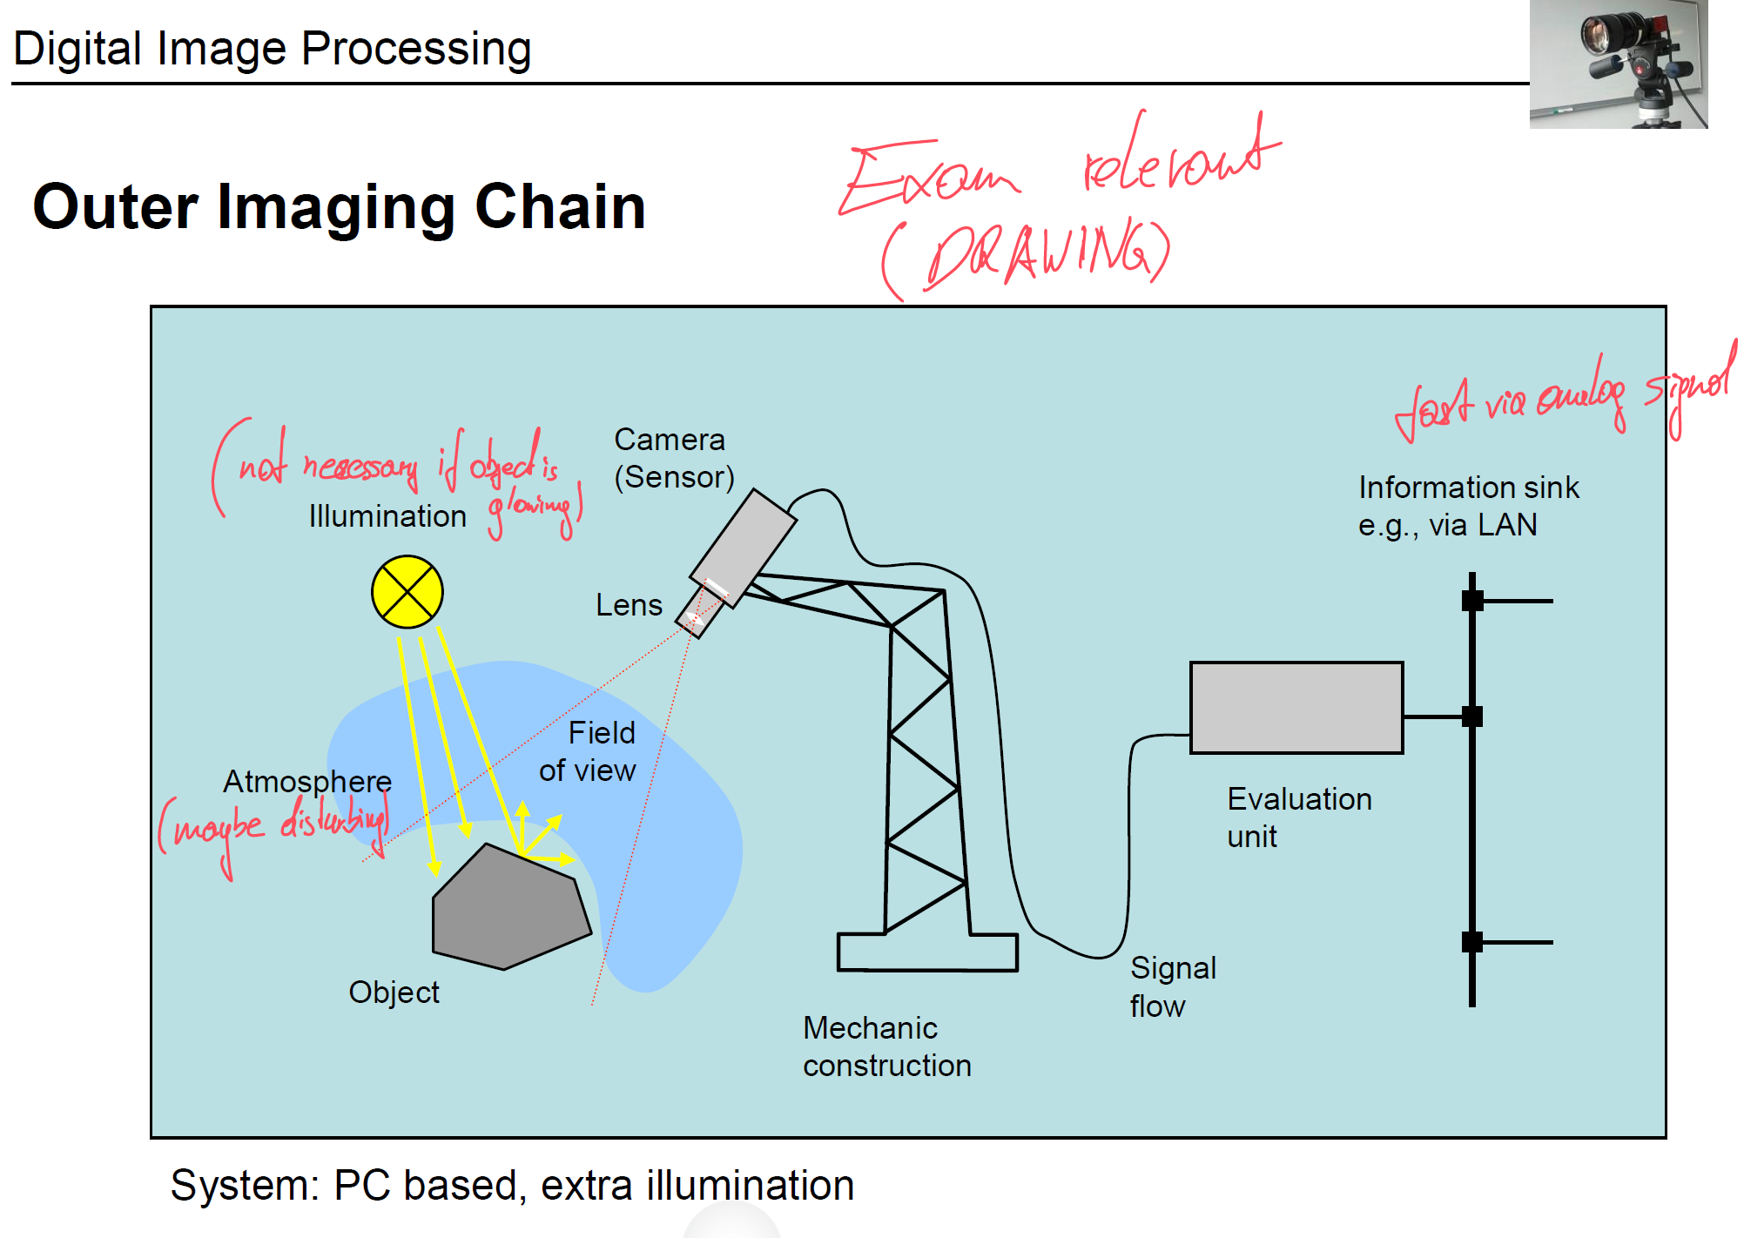
* What is the meaning of CCD, CMOS sensor (two possibilities )
* What is the difference between the photodiode and CCD? (p. 26)
  + CCD – charge coupled device
    - 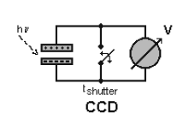
    - Including transistors for evaluation – APS “active pixel sensor”
    - Picture elements – pixel – are capacitors which are charged by luminous flux
    - At defined shutter speed the charging voltage corresponds to image brightness
    - Transistor additionally to the capacitor – analog in CMOS technology
    - Fill factor decreases (CCD ~ 90% / CMOS ~30%)
    - HDR – High Dynamic Range
  + CMOS
    - 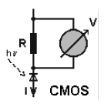
    - Impact of photons affects conductance
    - Continuous image conversion
    - No shutter time
    - Reading of certain regions within the image possible
    - High noise
  + Procedure how to get the image (4 steps )

1. Discharge -> Up=0V
2. Exposure CCD Et~0,5-20ms
3. Stop exposure
4. Readout -> shift register

* What is the meaning of colour perception (capturing)(two different options - sketch)
  + 3 CCD sensors (expensive.... with prisms)

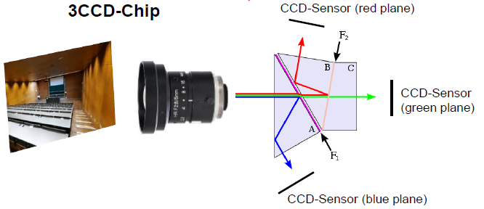

* + Four pixels – 2 green, 1 red, 1 blue – mosaic

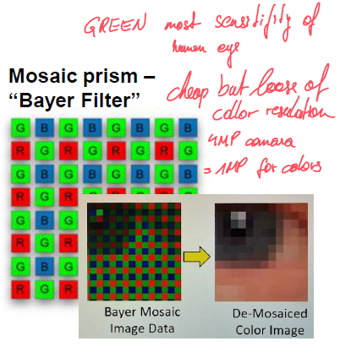

* Meaning and result of HDR – how does it work (relationship grey level, brightness...)
  + High dynamic range
  + **Multiple Exposures**: HDR involves capturing multiple images of the same scene at different exposure levels (e.g., underexposed, correctly exposed, and overexposed).
  + **Combining Data**: These images are combined to preserve the details in both the brightest and darkest areas.
  + **Tone Mapping**: The combined data is then compressed into a format that can be displayed on standard devices, ensuring balanced brightness and contrast.
  + **Result**: The final image appears more detailed and closer to what the human eye perceives, especially in scenes with high contrast (e.g., bright skies and dark shadows).
* What is the meaning/ advantage of the event based camera?
  + No frame by frame capturing – reacts on events – change in brightness
  + Static image – no events – no output
  + Dynamic image – registers only changing events per pixel
  + Down to 1200 events per second
* Please name 3 main features of the camera (p. 37)
  + **Geometry:** matrix/area scan, line scan
  + **Video Signal:** analog, digital camera
  + **Sensor type:** 
    - CCD, CMOS, photo diode array
    - BW, colour
    - Special cameras – e.g. thermal imaging
    - Capturing procedure: interlaced, non interlaced = progressive Scan
  + Intelligent cameras: capturing device including evaluation device
  + Price: €500,- to €2.000,-
  + Mounting
* Model of thin Lense model and pinhole model (p. 44 & p.41)

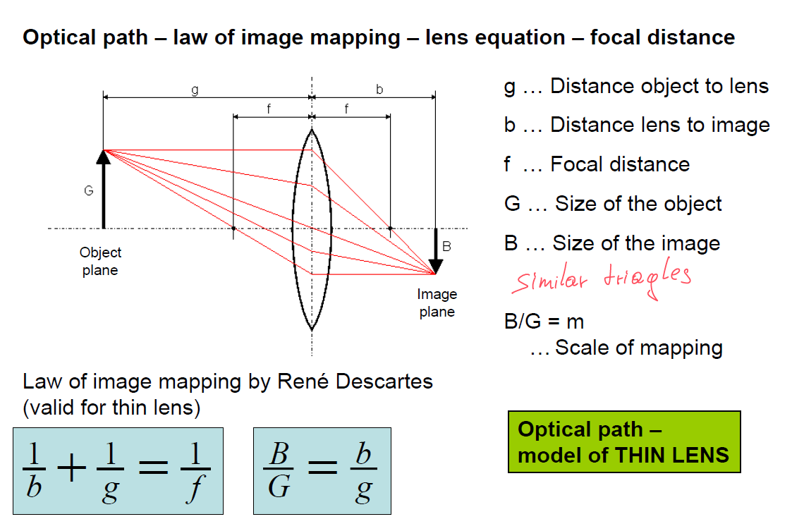

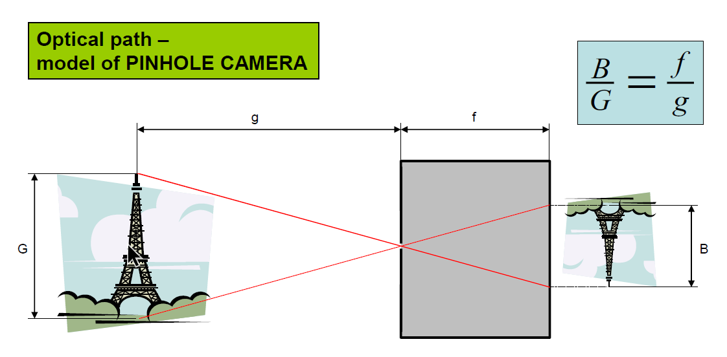

* + Calculation (no need to know standardised formats)
  + Meaning of the format: in inch – diameter from glass tube (camera tube) - historical
* What is the meaning of the iris? (p. 43)

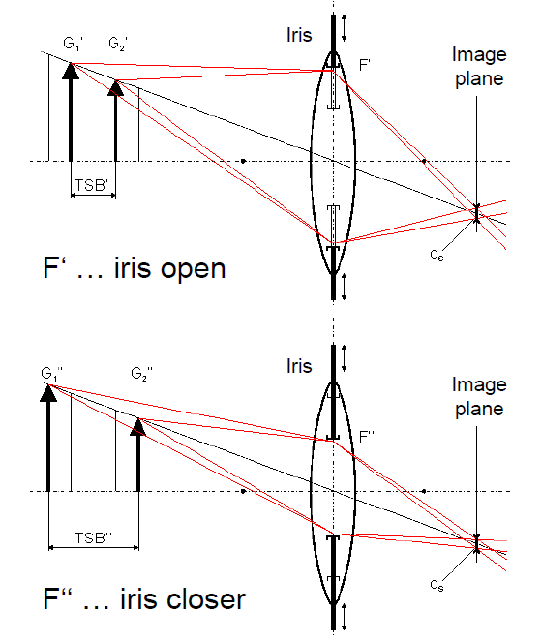

* + What numbers can the iris take?
    - F-numbers values between 1.0 and ∞ (typical 1.0; 1.2; 1.4; 1.8; 2.0; …; 8.0; 11.0; 16.0;
  + What is the meaning of the depth of sharpness?
    - range in an image where objects appear in focus
  + Relationship of depth of sharpness and the f-number of the iris?
    - Big f-number ->big depth of sharpness
  + Relationship of depth of sharpness and the opening of the iris?
    - Bigger iris -> smaller depth of sharpness
* What is about the Rayleigh resolution criterion (p.45)
  + is a standard used to define the minimum distance between two point sources of light for them to be distinguishable as separate in an optical system.

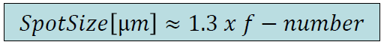

* Component of the illumination – 7 different options
  + **Transmitted light** – transparent object for certain spectral wavelength



* + **Silhouette projection** – shadow detected – binary image – for precise measurements



* + **Diffuse illumination** – no shadows



* + **Bright field** – appearance of reflecting objects within dark ambience



* + **Dark field** – notches, scratches on reflecting objects



* + **Shade projection** – while grey levels of objects and background are similar



* + **Structured illumination** – outline and features of 3D objects are measured



* + Make a assumption on a given task
  + Properties of the illumination
* 4 different illumination sources ?? (p.54)
  + **Fluorescent tube** – bright homogeneous light, brightness oszillates by 100Hz

Therefore HF power supply unit (e.g. 2kHz), 3 phases (1 tube for each phase)

* + **Halogen bulb** – powered by controlled DC -> precise metrology using IR/vis. -reflectors (glas fibre) – just vis. light goes to object -> no extra heat ->”cold light source”
  + **Light emitting diode LED** – high life cycle (15k h – 30k h), short pulses, IR-LED
  + **LASER** – structured light, mostly red, monochrome light
* Different software approaches – 3 different types (p. 68)

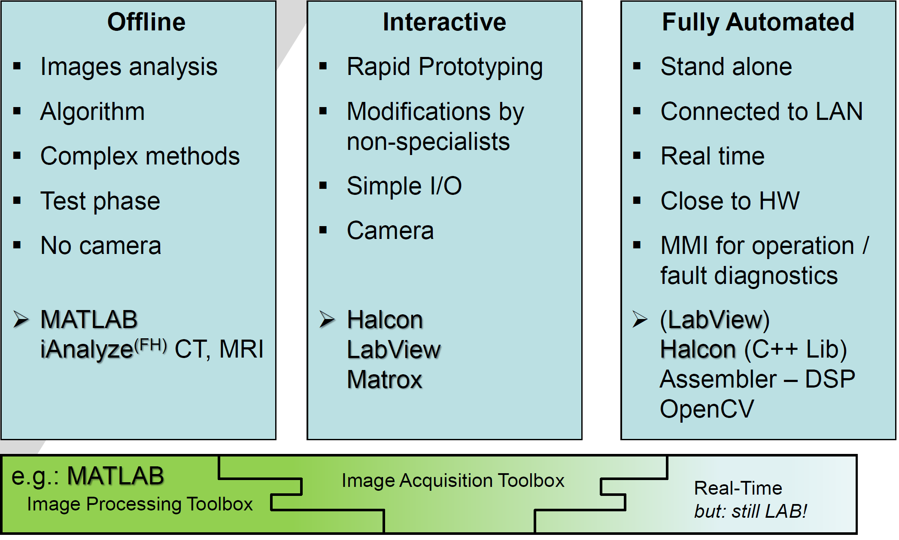

* Different calc methods for distances (p. 60)

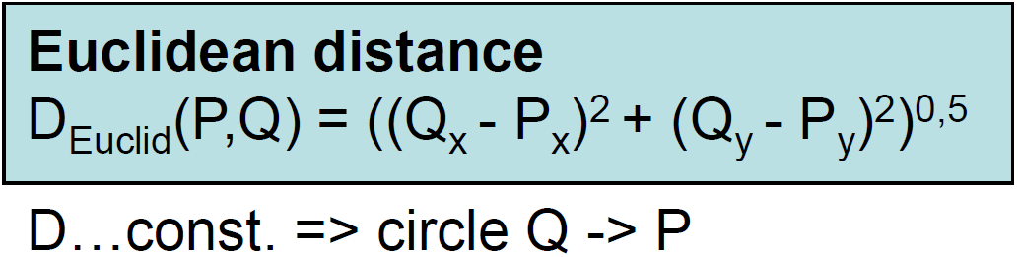 - high computational costs

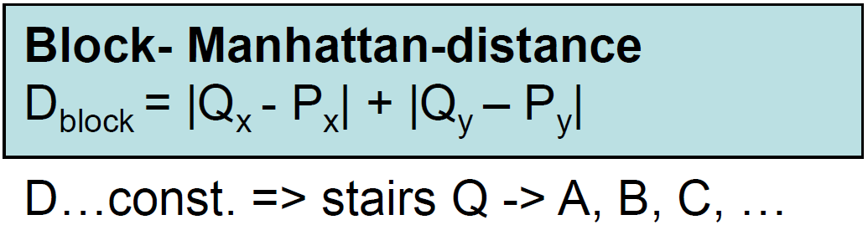 - bigger value than chess board



* What is the meaning of connectivity? (p.61)

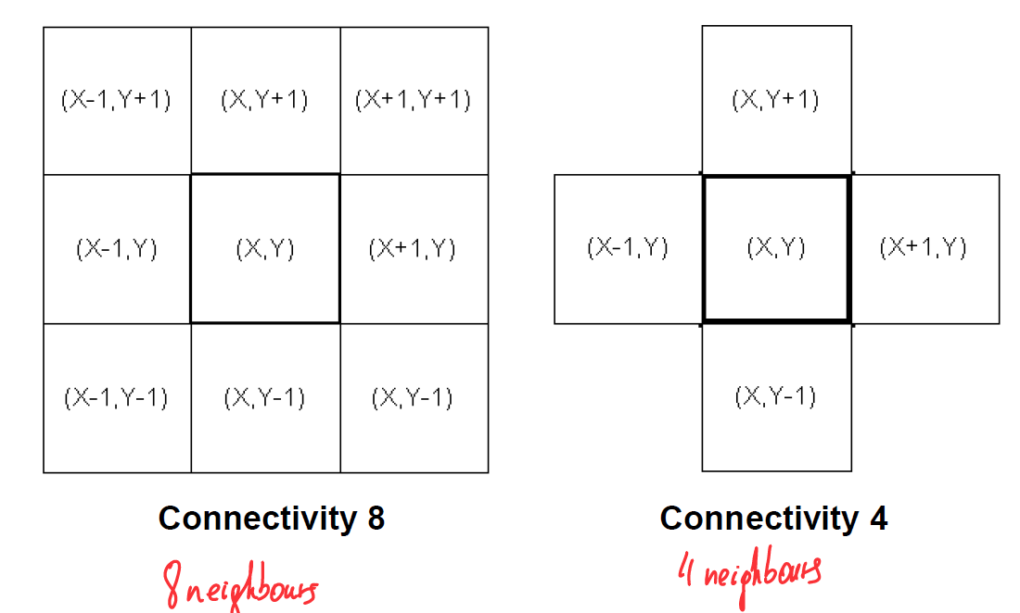

Difference in BLOB-analysis (Binary Large OBjects) – which objects get connected and which not

* What is the meaning of binarization?

Converting a grayscale image to a binary image (BW)

* + Advantages:
    - Simplifies image data – faster and mare efficient process
    - Useful for feature extraction, like text or object detection
  + Disadvantages
    - Loss of detail (no grayscale information)
    - Highly sensitive to lighting and noise – leads to inaccurate results
* Morphological filters

Modifies the shape of objects

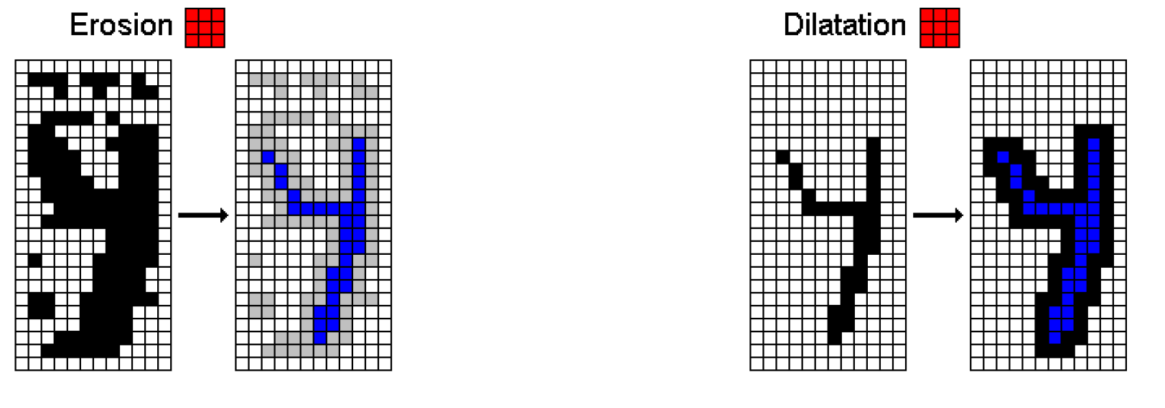

* + Erosion – shrinks objects by removing pixels at boundaries
  + Dilatation – expands object by adding pixels to the boundaries
* Convolution filter kernels – meaning (p. 75)

... are small matrices used to apply operations like blurring, sharpening, or edge detection by sliding over an image and computing weighted sums of pixel values.

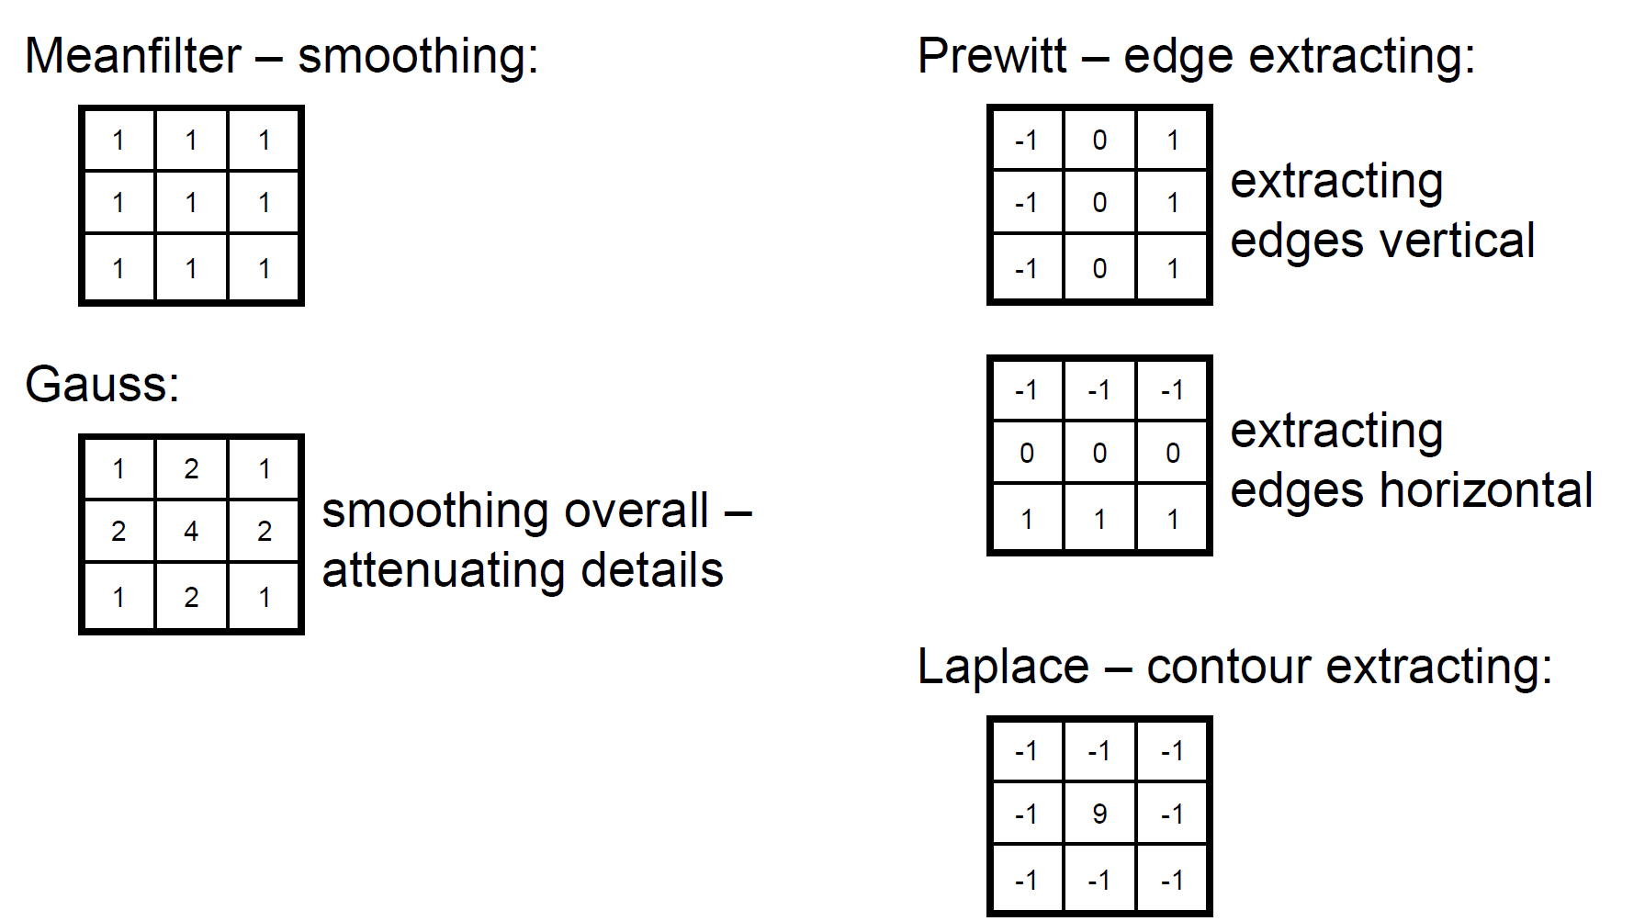

* 3 different way to measure the Z coordinates – main features, why each???
  + Time of light
    - Light power is modulated triangular or sinusoidal by frequency
    - The frequency of the reflected signal differs from the frequency of the actual transmitted signal – beat frequency Δf by heterodyne (Schwebungssatz durch Überlagerung)
    - To avoid the exact detection of the frequencies fFM and Δf reference signals are taken
  + Stereography
    - Both image planes are identical
    - Both optical axis are parallel
    - Lines of the stereo images are parallel to the base line



* + Structured light
    - Projection of beams of light – point at the objects
    - Projection of planes of light . line at the object
    - Coded structured light
    - Projection binary pattern
    - Triangulation using two cameras
    - Calibration is important



* Describe summary terms of stereography
  + *Pinhole*  
    uses a small aperture to project an inverted image onto a photosensitive surface
  + *Baseline*   
    refers to the distance between two observation points (or cameras) used to create depth perception in 3D imaging
  + *Standard geometry*  
      
    - both imaging planes are identical
    - both optical axis are parallel
    - lines of the stereo images are parallel to the base line
  + *Disparity*  
    difference in image location of an object seen by each camera; circular for depth perception in 3D imaging
  + *Rectification of the real geometry*  
    refers to the process of aligning images from two cameras to a common plane; simplifying disparity calculation an enhancing 3D depth accuracy
  + *Epipolar geometry*  
    defines geometric relationship between two camera views, constraining corresponding image points to lay along epipolar lines
  + *Depth resolution*  
    is the accuracy in measuring depth differences between objects, influenced by factors like baseline distance and camera resolution
* Depth resolution formula + calculation

The depth resolution is the minimal distance ΔH which a point has to move in the direction of the beam of one camera to cause a shifting at the other camera by the pixel distance Px

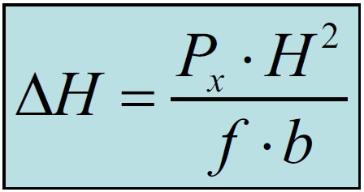

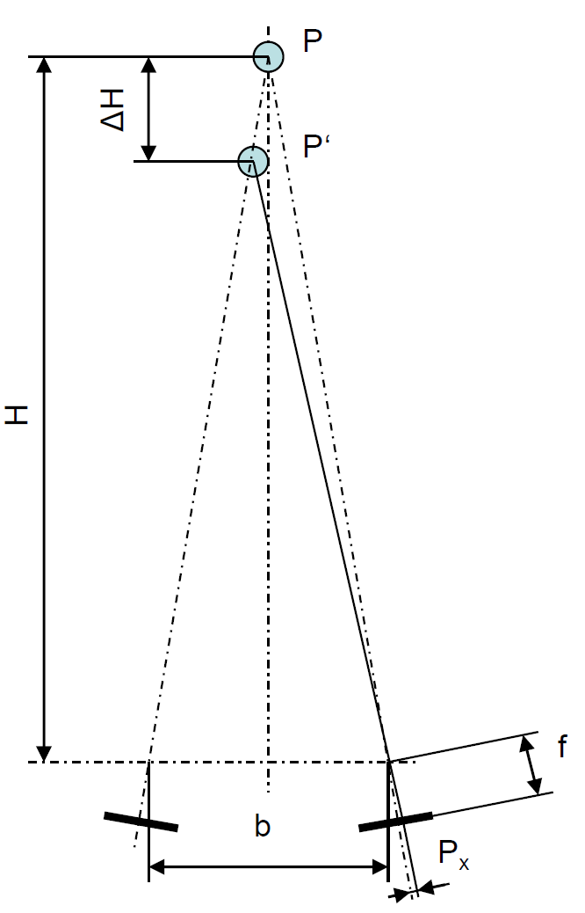

## 2nd slide set

* Meaning of homography (p. 5)

Is often used for perspective correction – transfers points from a object plane to a image plane

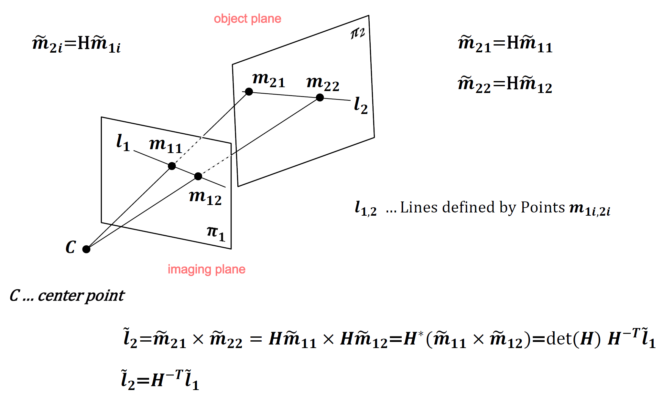

* Hierarchy of the projective geometry (p. 9)
  + Euclidian
  + Affine
  + Projective



* Camera parameters, real-world with respect to the camera position (projective part of the camera position) – 3 different classes of the camera set parameters
* Estimation of the camera parameters

3 papers

Stereography, trends, calibration -> summary